中心Centre: |  |  |  |  |  | 日期Date:
使用者姓名Marked For: |  |  |  |  |  | 電話Tel:
聯絡人Contact: |  |  |  |  |  | 傳真Fax:
OT PT NS SW Relatives |  |  |  |  | Email:
地址Address:

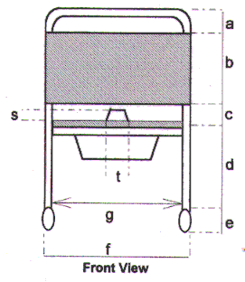 | 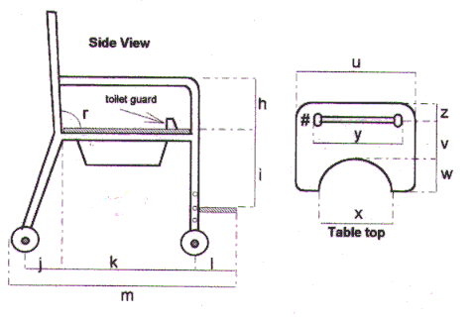
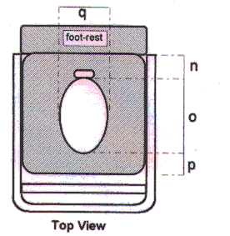  訂製To order pc (s) 件  Diameter of s.steel tube :  不銹鋼通直徑為 : 1” inch  Remarks: | With seat board / cushion* With back cushion  Fixed arm-rest Detachable arm-rest  Fixed foot-rest Detachable foot-rest  Height adjustable foot-rest No foot-rest needed  2 front / 2 rear / 4* castors With / without toilet guard  No / front / rear / all* castor(s) with brakes  With table top With hand-hold
 | Measurements Unit: ( inches / cm )
 | a. | b. |  | c.
 | d. | e. |  | f.
 | g. | h. |  | i.
 | j. | k. |  | l.
 | m. | n. |  | o.
 | p. | q. |  | r.
 | s. | t. |  | u.
 | v. |  | W, |  | y.
 | z.

